# Introduction

* 1. **Background and Motivation**

The topic that I have chosen for this project is road traffic injuries in Australia. Road traffic accidents are one of the world’s largest public health and injury prevention problems. Australia has seen over 190,000 fatalities since an accurate car record commenced in 1925. The reason that for choosing this topic is to gain more understanding about road traffic injuries. This project would be beneficial for all citizens who are living in Australia.

* 1. **Project Objective**
* How many deaths are caused by road traffic accident in Australia?
* What are the types of road user which cause road traffic deaths?
* What is the proportion of road traffic deaths by age range.

**List of benefit:**

* The users would understand the rate of road traffic deaths cases through observing the completed visualisation.
* Encourage users to explore and manipulate the data to uncover other factors that cause road traffic injuries.
  1. **Project Schedule**

Week 1: Understand the concept of data visualisation

Week 2: Learning about D3 and data visualisation outline

Week 3: Learning about D3 Axis and Scales

Week 4: Make a project proposal

Week 5: Obtain data from reliable website

Week 6: Sketching design for the project

Week 7: Project Progress report, including prototype phrase and simple web application

Week 8: Project Progress report, done prototype and add-in some features.

Week 9: user testing

Week 10: Optimized the data visualisation from the feedback that collected from the users

Week 11: Data Visualisation presentation.

# Data

* 1. **Data Source**

I obtain the data from the reports that published from Australia Government, department of infrastructure, regional development and cities <https://bitre.gov.au/publications/ongoing/road_deaths_australia_annual_summaries.aspx>. The website contain many datasets which are needed in the project such as Road traffic deaths and Road traffic deaths by type of road user.

Furthermore, I will also take data set from other report that published from National Road Safety Strategy <https://roadsafety.gov.au/performance/road-deaths-age-group.aspx>. This website contain road deaths by age group in Australia which is needed in this project.

The data source provided by these official websites are in Excel file type with 56 tables of data sets. The attributes in data set are mostly region, year, population, and type of road user, genders, and number of deaths.

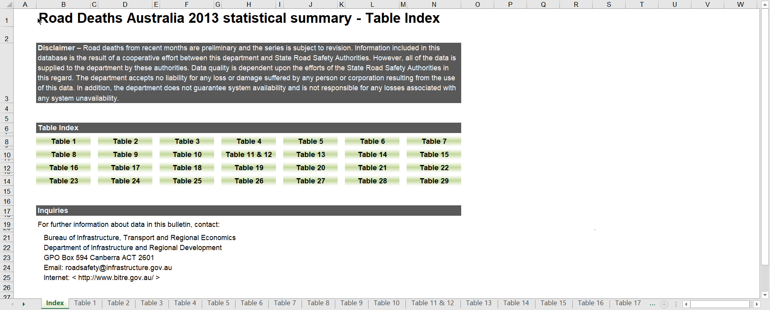

figure : Data souce from Australia Government website

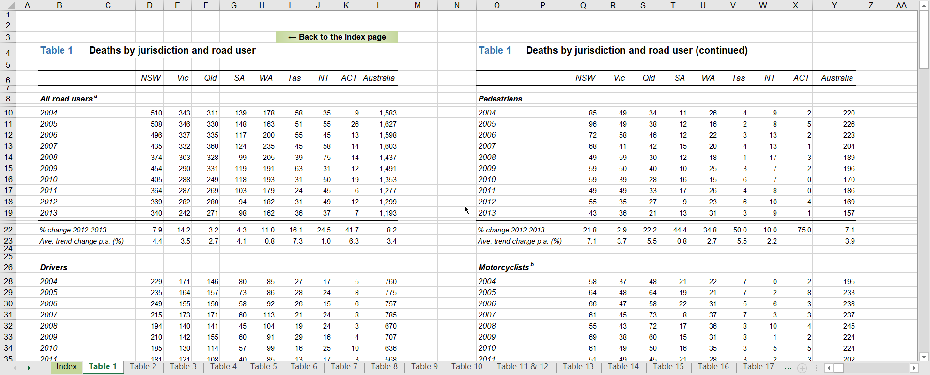

figure : One of the table from data source

* 1. **Data Processing**

Since the data source is already cleaned and legit, I do not plan to do substantial data cleanup. However, I do taking the table sets that are necessary for the project. And also I change some of the variable names like replace the space by dashline and convert the file to csv so it can be read by d3.

# Requirements

* 1. **Must-Have Features**

I have considered a hover feature in this project. For example, a data will be shown whenever the mouse move to any bar in the bar chart. And also, I would also consider a button that can switch data. For example if there are two button 2017 and 2018, when user click on 2017 button, it will show 2017 data visualisation. Furthermore, I also plan to implement transition when changing the data.

* 1. **Optional Features**

A bootstrap implementation would be the optional feature for this project. It would be nice to have because it can capture the interest of the audience and makes an good impression. And also, I plan to implement interaction between each visualisation. Like if reader click on any data in first chart, the second chart change the data as well. It connects each data set and it could catch reader attraction.

# Visualisation Design

For this project, I plan to do 2 visualisation which are line chart and bar chart. I plan to use multiple lines as mark for number of road traffic injuries and colors as visual channels to represent different age groups. As for bar chart, I plan to use genders to represent the number of injuries in each categories of road users. There will be 2 button to switch the data between male and female.